CSE246

Section 4

Fall 2023

**Lab Task - 03**

**Topic:** Basic Prime Checking

Finding the Pattern’s occurrences

Calculate Prefix Function of a String

Submitted By

|  |  |
| --- | --- |
| **Name** | **ID** |
| B M Shahria Alam | 2021-3-60-016 |
| Golam Kibria | 2021-3-60-215 |
| Sidratul Moontaha | 2021-3-60-048 |
| MD Imran Khan | 2021-3-60-206 |

**Problem 1**

**Solution:**

#include<bits/stdc++.h>

using namespace std;

const long long N = 1e9+5;

int main()

{

int t;

cin>>t;

while(t--)

{

int n;

cin>>n;

if(n==1)

{

cout<<"NOT PRIME\n";

continue;

}

int flag = 1;

for(int i = 2; i*i<=n; i++)

{

if(n%i==0)

{

flag=0;

break;

}

}

if(flag==1|| n==2)cout<< "PRIME" <<endl;

else cout<< "NOT PRIME" <<endl;

}

return 0;

}

**OUTPUT:**

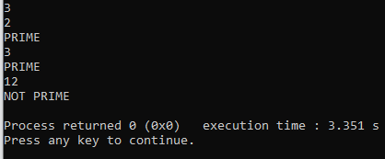

**Problem 2**

**Solution:**

#include<bits/stdc++.h>

using namespace std;

#define d 26

#define q 101

void search( string pattern, string text) {

int M = pattern.length();

int N = text.length();

int p = 0;

int t = 0;

int h = 1;

for (int i = 0; i < M - 1; i++)

h = (h * d) ;

for (int i = 0; i < M; i++) {

p = (d * p + pattern[i]) %q;

t = (d * t + text[i]) %q ;

}

for (int i = 0; i <= N - M; i++) {

if (p == t) {

int j;

for (j = 0; j < M; j++) {

if (text[i + j] != pattern[j])

break;

}

if (j == M) {

cout << i << " " << i + M - 1 << endl;

}

}

if (i < N - M) {

t = (d * (t - text[i] * h) + text[i + M]) % q;

if (t < 0)

t = t + q;

}

}

}

int main()

{

string T, P;

cin >> T >> P;

search(P, T);

return 0;

}

**OUTPUT**

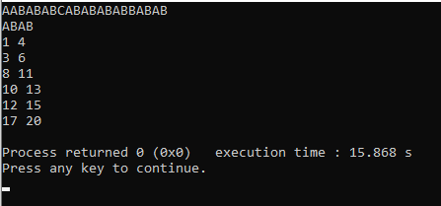

**Problem 3**

**Solution:**

#include<bits/stdc++.h>

using namespace std;

vector<int> prefix_pattern(string P)

{

int n = P.length();

vector<int> pi(n);

for (int i=1; i<n; i++)

{

int j = pi[i-1];

while (j>0 && P[i]!=P[j])

{

j= pi[j-1];

}

if (P[i]==P[j])

{

j++;

}

pi[i]=j;

}

return pi;

}

int main()

{

string P;

getline(cin, P);

vector<int> pi = prefix_pattern(P);

for (int i = 0; i < pi.size(); i++)

{

cout << pi[i] << " ";

}

return 0;

}

**OUTPUT:**

